**EXCEL FORMULAS**

**SUM:**

**Syntax**

**=SUM**(**number1**,number2, ...)

**Number1, number2, ...**   are 1 to 255 arguments for which you want the total value or sum

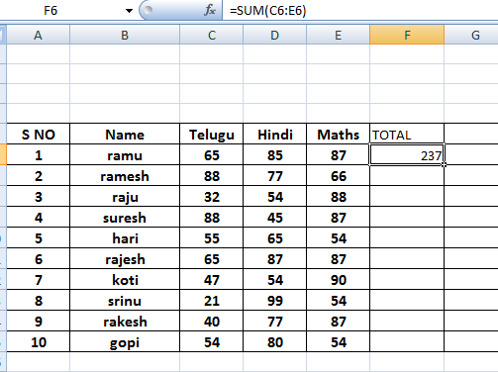

**AVERAGE**

**Syntax**

**=AVERAGE**(**number1**,number2,...)

**Number1, number2, ...**   are 1 to 255 numeric arguments for which you want the average.

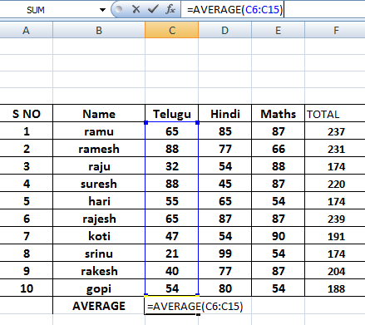

**PERCENTAGE**

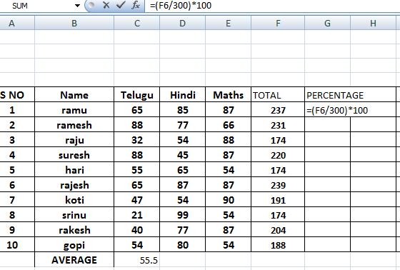

**IF AND NESTED IF**

**Syntax**

**IF**(**logical_test**,**value_if_true**,value_if_false)

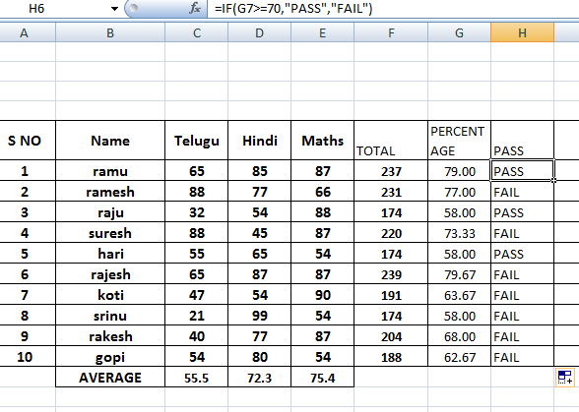

**NESTED IF**

**Syntax**

**IF**(**logical_test**,**value_if_true**,value_if_false)

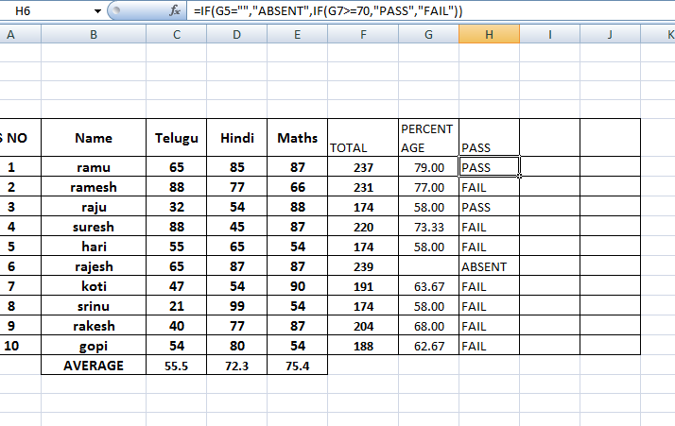

**INDIRCET**

**=INDIRECT**(**ref_text**,a1)

**Ref_text**   is a reference to a cell that contains an A1-style reference, an R1C1-style reference, a name defined as a reference, or a reference to a cell as a text string. If ref_text is not a valid cell reference, INDIRECT returns the #REF! error value.

* If ref_text refers to another workbook (an external reference), the other workbook must be open. If the source workbook is not open, INDIRECT returns the #REF! error value.
* If ref_text refers to a cell range outside the row limit of 1,048,576 or the column limit of 16,384 (XFD), INDIRECT returns a #REF! error.

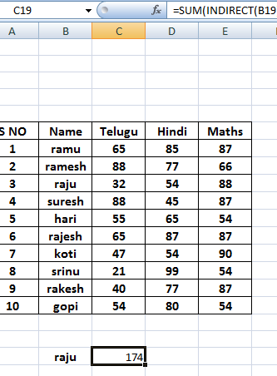

**MATCH:**

**Syntax**

**MATCH**(**lookup_value**,**lookup_array**,match_type)

**Lookup_value**   is the value you use to find the value you want in a table.

* Lookup_value is the value you want to match in lookup_array. For example, when you look up someone's number in a telephone book, you are using the person's name as the lookup value, but the telephone number is the value you want.
* Lookup_value can be a value (number, text, or logical value) or a cell reference to a number, text, or logical value.
* 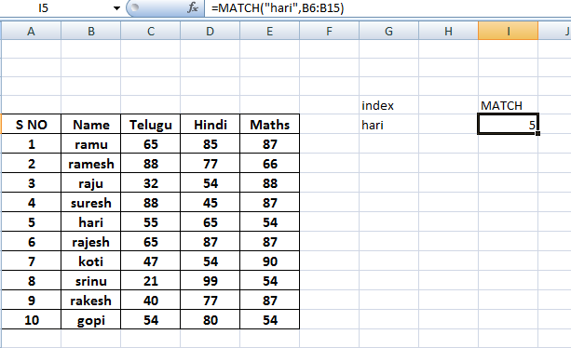

**INDEX:**

**=INDEX**(**array**,row_num,column_num)

**Array**   is a range of cells or an array constant.

* If array contains only one row or column, the corresponding row_num or column_num argument is optional.
* If array has more than one row and more than one column, and only row_num or column_num is used, INDEX returns an array of the entire row or column in array.

**Row_num**   selects the row in array from which to return a value. If row_num is omitted, column_num is required.

**Column_num**   selects the column in array from which to return a value. If column_num is omitted, row_num is required.

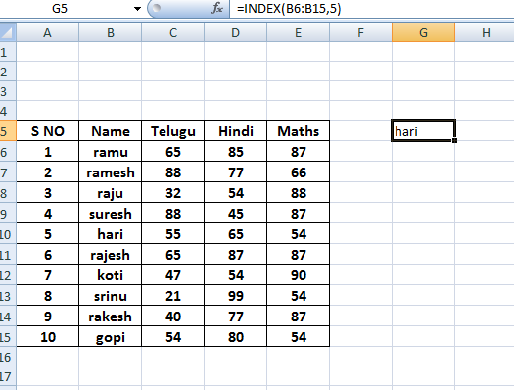

**COUNT:**

**Syntax**

**=COUNT**(**value1**,value2,...)

**Value1, value2, ...**   are 1 to 255 arguments that can contain or refer to a variety of different types of data, but only numbers are counted.

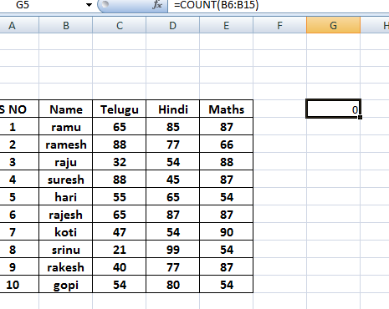

**COUNTA:**

**Syntax**

**=COUNTA**(**value1**,value2,...)

**Value1, value2, ...**   are 1 to 255 arguments representing the values you want to count.

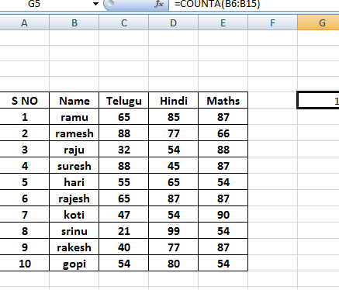

**TODAY,NOW,DATE AND TIME**

**Syntax**

**=TODAY**( )

**Syntax**

**=DATE**(**year**,**month**,**day**)

**Syntax**

**=NOW**( )

**Syntax**

**=TIME**(**hour**,**minute**,**second**)

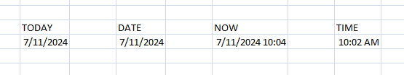

**PROPER,LOWER AND UPPER**

**Syntax**

**=PROPER**(**text**)

**Syntax**

**=UPPER**(**text**)

**Syntax**

**=LOWER**(**text**)

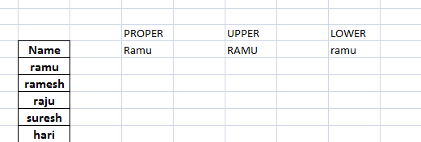

**ROUND, ROUNDDOWN AND ROUNDUP**

**Syntax**

**ROUND**(**number**,**num_digits**)

**Number**   is the number you want to round.

**Num_digits**   specifies the number of digits to which you want to round number.

**Syntax**

**ROUNDDOWN**(**number**,**num_digits**)

**Number**   is any real number that you want rounded down.

**Num_digits**   is the number of digits to which you want to round number.

**Syntax**

**ROUNDUP**(**number**,**num_digits**)

**Number**   is any real number that you want rounded up.

**Num_digits**   is the number of digits to which you want to round number.

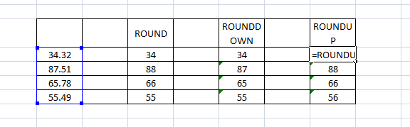

**CONCATENATE**

**Syntax**

**=CONCATENATE** (**text1**,**text2**,...)

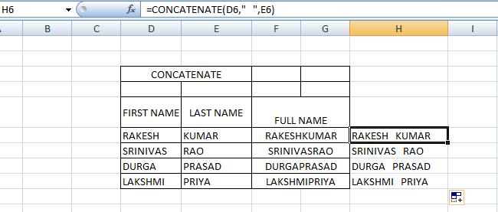

**REPLACE**

**Syntax**

**=REPLACE**(**old_text**,**start_num**,**num_chars**,**new_text**)

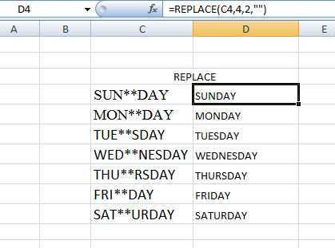

**REPEAT:**

**Syntax**

**=REPT**(**text**,**number_times**)

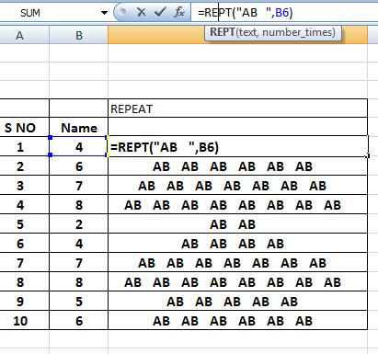

**VLOOKUP**

**Syntax**

**VLOOKUP**(**lookup_value**,**table_array**,**col_index_num**,range_lookup)

**Lookup_value**  The value to search in the first column of the table [array (array: Used to build single formulas that produce multiple results or that operate on a group of arguments that are arranged in rows and columns. An array range shares a common formula; an array constant is a group of constants used as an argument.)](javascript:AppendPopup(this,'xldefArray_1')). Lookup_value can be a value or a reference. If lookup_value is smaller than the smallest value in the first column of table_array, VLOOKUP returns the #N/A error value.

**Table_array**  Two or more columns of data. Use a reference to a range or a range name. The values in the first column of table_array are the values searched by lookup_value. These values can be text, numbers, or logical values. Uppercase and lowercase text are equivalent.

**Col_index_num**  The column number in table_array from which the matching value must be returned. A col_index_num of 1 returns the value in the first column in table_array; a col_index_num of 2 returns the value in the second column in table_array, and so on. If col_index_num is:

* Less than 1, VLOOKUP returns the #VALUE! error value.
* Greater than the number of columns in table_array, VLOOKUP returns the #REF! error value.

**Range_lookup**  A logical value that specifies whether you want VLOOKUP to find an exact match or an approximate match:

* If TRUE or omitted, an exact or approximate match is returned. If an exact match is not found, the next largest value that is less than lookup_value is returned.

The values in the first column of table_array must be placed in ascending sort order; otherwise, VLOOKUP may not give the correct value. For more information, see [Sort data](ms-help://MS.EXCEL.12.1033/EXCEL/content/HP10073947.htm).

* If FALSE, VLOOKUP will only find an exact match. In this case, the values in the first column of table_array do not need to be sorted. If there are two or more values in the first column of table_array that match the lookup_value, the first value found is used. If an exact match is not found, the error value #N/A is returned.

